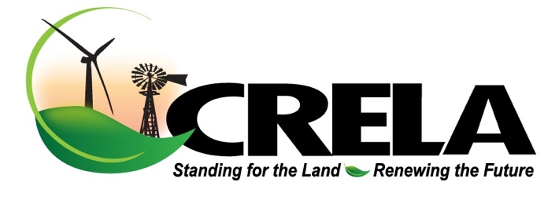

2993 Quay Road 61
Tucumcari NM 88401
www.crelanm.com

January 28, 2025

U.S. Department of Energy,
Grid Deployment Office,
1000 Independence Ave. SW, Suite 4H-065,
Washington, DC 20585.

On behalf of the Board of Directors and membership, We are writing in opposition to the designation of a National Interest Electric Transmission Corridor in Eastern New Mexico, Western Oklahoma and Southeast Colorado. This is referenced under docket number DOE HQ-2024-0089 as the Southwest Grid Connector.

As an organization of private landowners, we have sought and continue to seek opportunities for renewable development for landowners and rural communities and in doing so, we realize the reality of the need for development of upgraded transmission to move the wind and solar resource. We have been proactive and engaged to this end to seek and achieve development and transmission solutions that benefit all stakeholders in a prudent and responsible way that most importantly maintains land value and the right of the landowner to utilize their property for their best possible benefit, whether as a renewable project participant or not.

This proposal as it is written does not convince us in any way that the most critical stakeholders, the private landowner, will benefit in the long run. Your proposal creates a corridor in varying widths from five to fifteen miles wide. In earlier versions (Phases I and II), these corridor paths were even far wider covering almost whole counties.

In your own NIETC Final Guidance document, on page 9, you have the following language:

“As for federal permitting tools unlocked by NIETC designation, under section 216(b) of the FPA, as amended by the IIJA, designation of a NIETC allows an interested party seeking to develop a transmission line to apply for a permit from FERC for the construction or modification of transmission facilities within a NIETC, provided that certain other statutory conditions have been met. At a high level, under certain circumstances, FERC may grant permits within a NIETC where a state does not have authority to site a transmission line or a state siting authority has not acted on an application to site a transmission line for over one year or has denied an application. This includes granting the transmission developer the ability to obtain rights-of-way by exercise of the right of eminent domain.”

This very statement is at the deep core of our concern and opposition. This grants the federal government enormous power and authority to permit and site transmission by any means necessary if the time frame is not suitable to either the developer or the Department of Energy.

The New Mexico Public Regulation Commission and the New Mexico Renewable Energy Transmission Authority have been the lead agencies within New Mexico for siting, permitting and financing. We as residents of New Mexico have the ability to attend their meetings and directly express concerns over any proposed actions that will harm private landowners. The same is true for Oklahoma and Colorado residents with their respective utility regulatory agencies.

We strongly oppose any designation of targeted area and the added DOE and FERC mandate granted with that designation that would usurp the authority of these agencies and our rights as citizens to interact with their board members and staff for the redress of grievances or concerns.

The designation of these targeted corridor areas coupled with the cloud of eminent domain provides a net result in an automatic decrease in land value and is additionally a blatant invasion of landowner rights and federal overreach. As you are aware federal code USC 824p outlines the procedure for siting of transmission and the use of eminent domain to achieve siting. Concerns have been raised that any land taken by eminent domain would be used for other purposes to basically create a new area of federal land in contradiction to Part E, Item 4 of USC 824p.

In researching this, we have not come across any press releases or public announcements from Xcel Energy, Public Service Company of New Mexico nor the Southwest Power Pool endorsing the Southwest Grid Connector concept nor its routing. While any or all of these entities may have submitted comments to the Federal Register in previous dockets, there has been no public outreach to rate payers or landowners in support of this concept.

As the major players and investors in transmission, would it not be wise and prudent to seek their input and planning resources to develop a plan that would actually achieve the goals of eliminating congestion and take load to centers where resources are deficient? In looking at this route, none of the cities along this line are major load centers in comparison to cities such as Albuquerque, Denver, Amarillo, Lubbock and Midland/Odessa or Arizona and California. There are billions of ratepayer dollars at stake and creating a corridor that does not allow cost recovery for the utility and actually serve to remedy load constraints makes absolutely no sense and is illogical.

All together our view and perception of this plan is nothing more than a preemptive move on the part of the Department of Energy and the Federal Energy Regulatory Commission to gain control of land resources and override state regulatory agencies if the time table for permitting and approval is too slow to appease a developer or the DOE itself.

We support working with transmission and development opportunities that identify a bona fide legitimate project with an end user power purchase agreement or working with a utility company or rural electric cooperative on projects of beneficial interest to us as landowners and ratepayers. We demand maximum engagement between the private landowner and the utility company or renewable developer. Eminent domain should never be threatened or implied at any time for any reason by governments or private entities.

It is always our contention that there should be fair and equitable negotiation between private landowners and developers/utilities/cooperatives for however long the process takes unencumbered by time constraints. Eminent domain should always be the path of extremely very last resort and only when it is determined that no other feasible alternatives exist for the benefit and security of the general public.

The Southwest Power Pool, Xcel and PNM along with the rural electric cooperatives should be the lead entities rather than the DOE or FERC in determining what is financially feasible for transmission upgrades and where the load deficiencies are. Micro management from Washington DC of transmission needs in Eastern New Mexico, the Oklahoma Panhandle and Southeast Colorado will not serve the best interests of private landowners and ratepayers.

We are asking that the Grid Deployment Office vacate the Southwest Grid Connection Corridor immediately and to recommit its efforts to working with the existing utilities, cooperatives and the Southwest Power Pool to engage in long range planning that protects private property rights and that makes economic sense to the entities and ratepayers.

Bill Brockman
Chairman
Coalition of Renewable Energy Landowner Associations

